Assignment Day6

Q1.Print default values of static & instance variables for different data types.

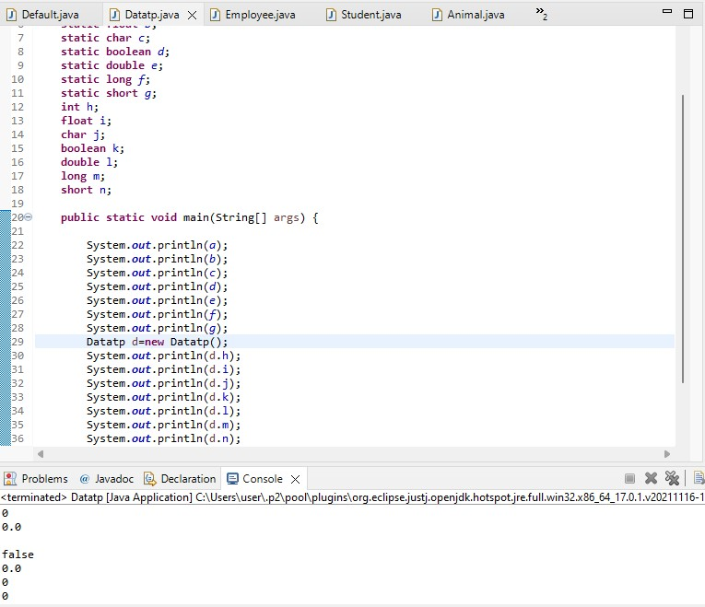

Q2. Build a class Employee which contains details about the employee and compile and run its instance.

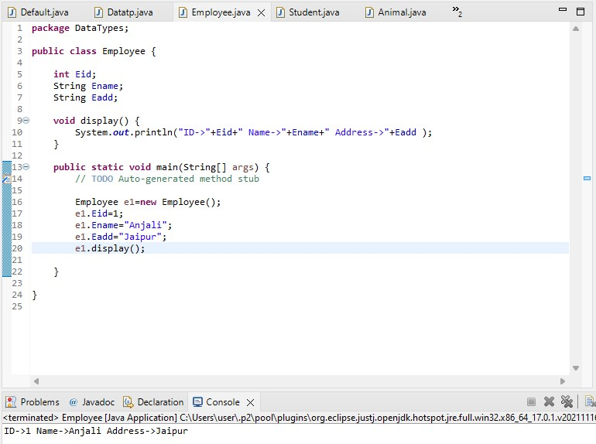

Q3. Create Student class with global variables and related methods with constructor and without constructor

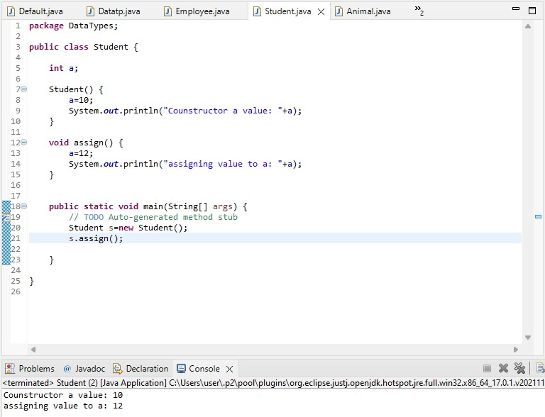

Q4. Create a class Vehicle and encapsulate the data members.

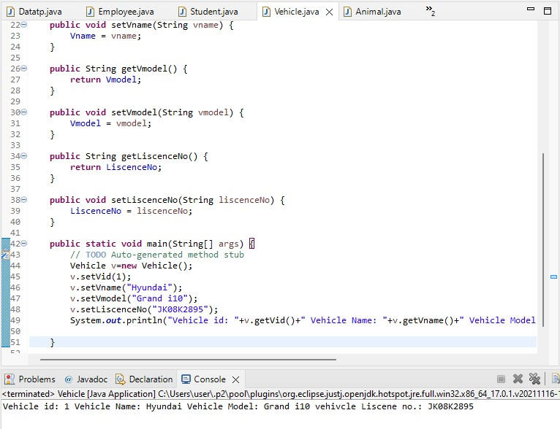

Q5. Create demo applications to illustrate different types of inheritance.

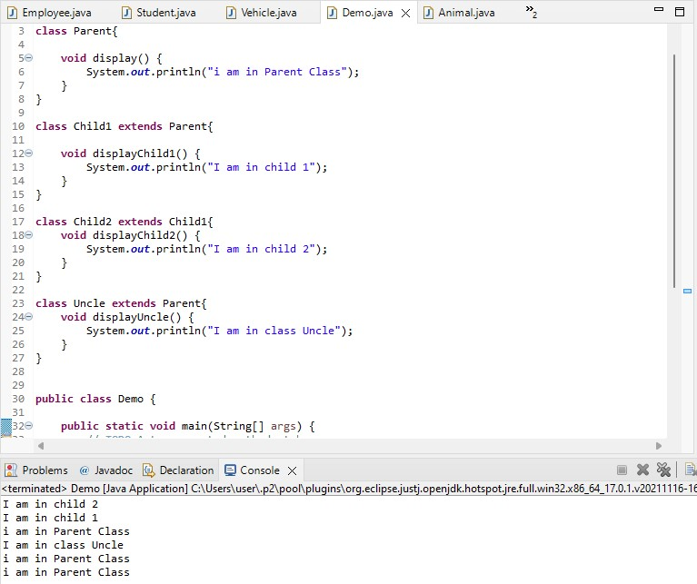

Q6.Create one Animal class(superclass), Dog class(subclass) the same method in the

